AI Assistant lab -19.3

Name:v.praneeth
Batch:41
Rollno:2303a52146

Task 1 – Python to C++ Conversion
Task:
Translate a simple Python class into C++ using AI assistance.
Instructions:
• Prompt AI to convert a Python class representing a Student with
attributes and methods into equivalent C++ code
• Ensure proper handling of:
o Constructors
o Data types
o Access specifiers
• Compile and run both versions to verify output consistency
Prompt
Convert a Python class Student with attributes name, age and a display() method into equivalent C++ code with constructor and proper access specifiers.
Python code
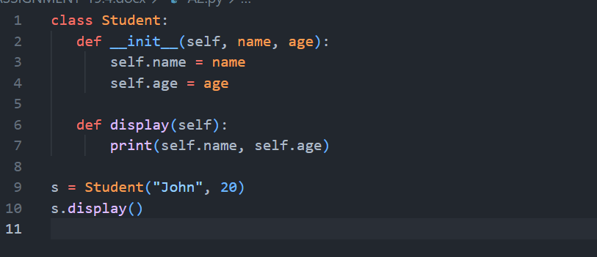
C++ code
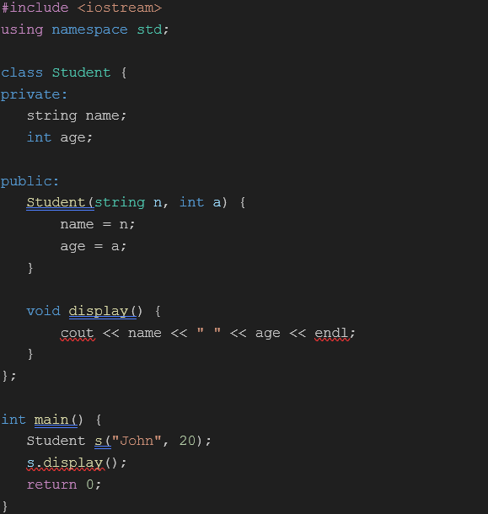
Output:
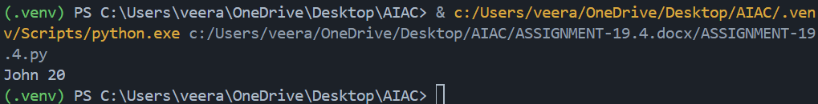

Justification
Constructor added explicitly in C++
Data types defined (string, int)
Encapsulation via private/public
Output verified same in both languages

Task 2 – Java to Python Function Conversion
Task:
Convert a Java method that checks whether a number is prime into
Python.
Instructions:
• Ask AI to translate a Java isPrime() method into Python
• Test the function with multiple inputs
• Ensure the Python version follows Pythonic syntax and logic
Prompt:
Convert Java method isPrime(int n) into Python function using Pythonic syntax.
Java code
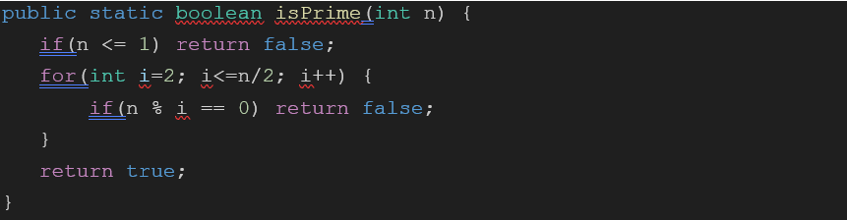
Python code
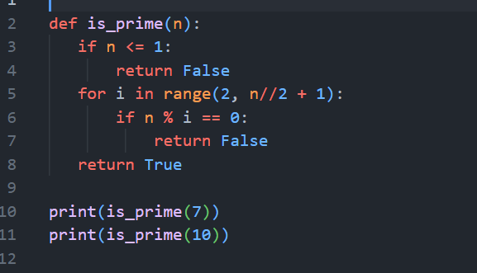
Output:
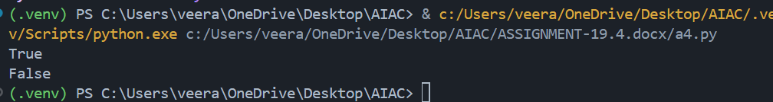
Justification
Python uses indentation instead of braces
range() replaces loop structure
Cleaner syntax (no type declaration)
Logic preserved exactly
Task 3 – Pseudocode to Python Implementation
Task:
Translate a given pseudocode algorithm into Python using AI.
Instructions:
• Provide AI with pseudocode for sorting numbers (e.g., bubble
sort or selection sort)
• Ask AI to convert it into executable Python code
• Validate correctness using sample input lists
Prompt
Convert bubble sort pseudocode into Python program.
Code
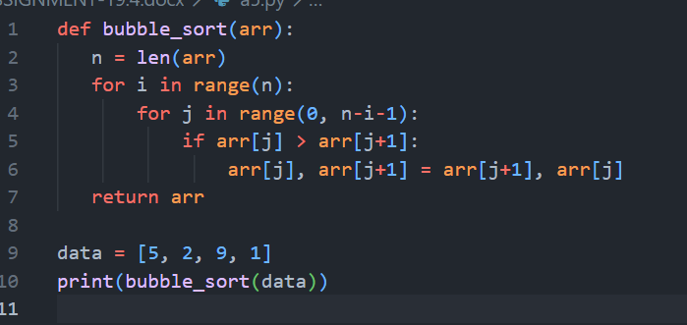
Output:
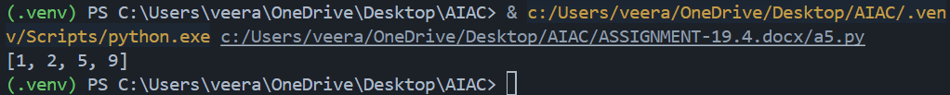
Justification:
Pseudocode loops directly mapped to Python loops
Swap done using tuple unpacking
Algorithm correctness verified
Task 4 – SQL to Pandas Query
Task:
Translate a SQL query into a Pandas DataFrame operation in
Python.
Instructions:
• Provide AI with a SQL query (e.g., SELECT name, salary FROM
employees WHERE salary > 50000).
• Ask AI to generate equivalent Pandas code.
• Test the generated code on a sample DataFrame
Prompt:
Convert SQL query SELECT name, salary FROM employees WHERE salary > 50000 into Pandas code.
Code
Sql query
ELECT name, salary
FROM employees
WHERE salary > 50000;
Python pandas code
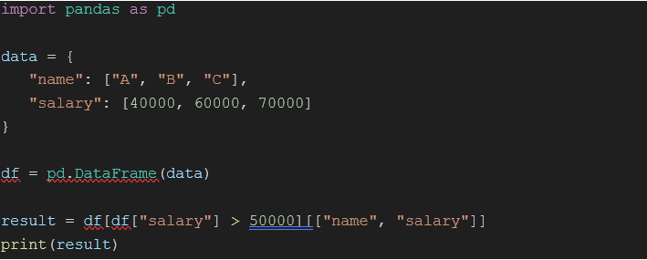Output:
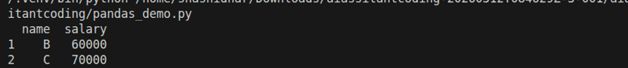

Justification
WHERE → Boolean filtering
SELECT → column selection
Equivalent data subset returned
Task 5 – Real-Time Application: Algorithm Translation Across
Languages
Scenario:
A company maintains algorithms written in different programming
languages.
Examples:
• Converting a Python searching algorithm into C
• Translating a Java sorting program into JavaScript
Instructions:
• Use AI to translate a selected algorithm between two
programming languages
• Execute and test both versions
• Document translation challenges such as:
o Syntax differences
o Library support
o Memory management
Prompt
Convert Python linear search algorithm into C language with proper memory handling.
Code
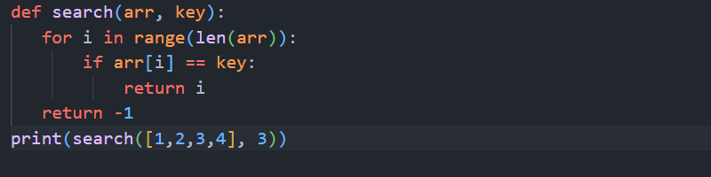
C code
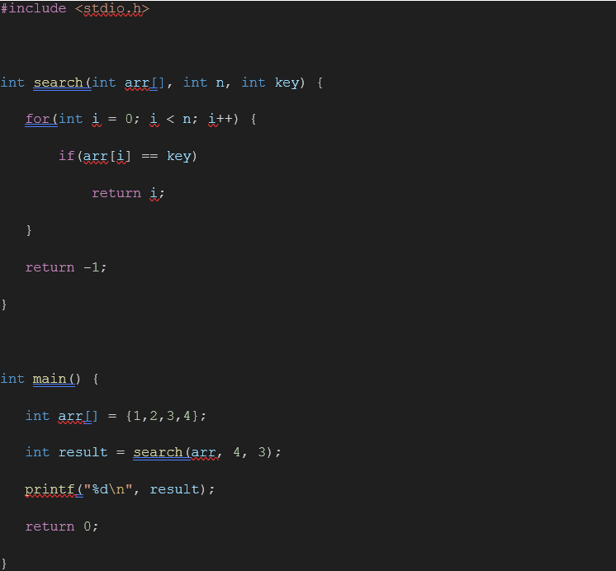
Output:
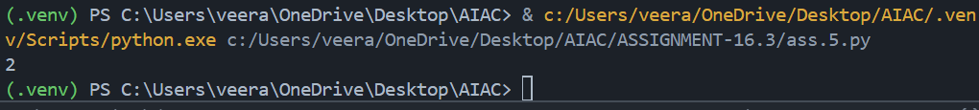

Justification
Manual array handling in C
No dynamic typing → explicit sizes required
Memory handled via static arrays
Same logic preserved

